**Associate Data Analyst in SQL DataCamp**

**Course 9: Data-Driven Decision Making in SQL**

**Introduction to business intelligence for a online movie rental database**

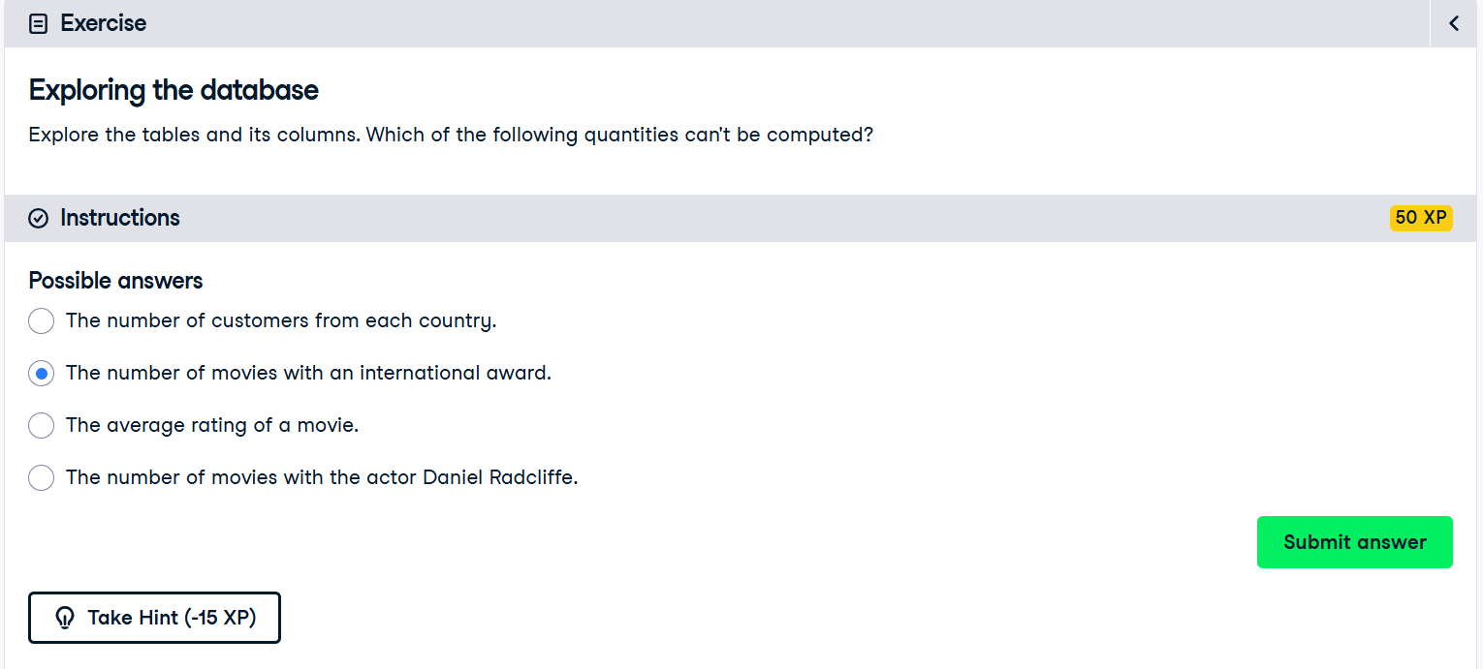

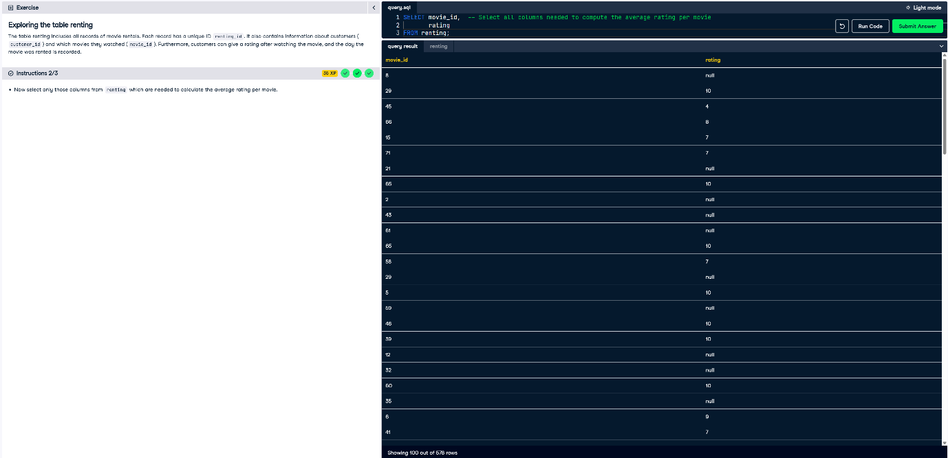

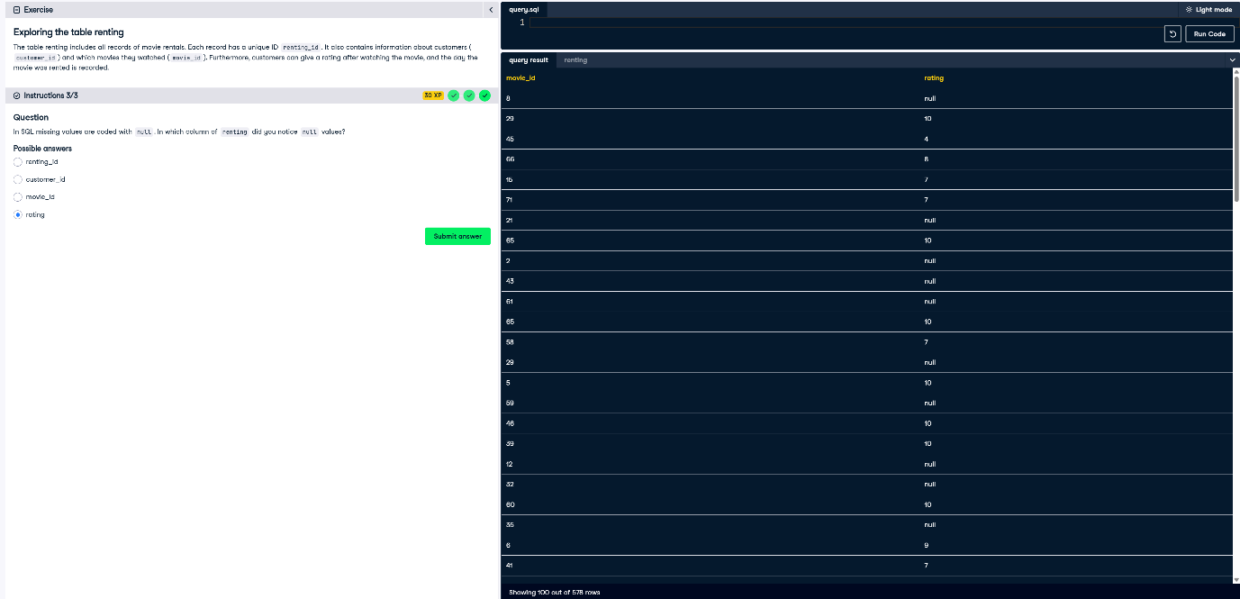

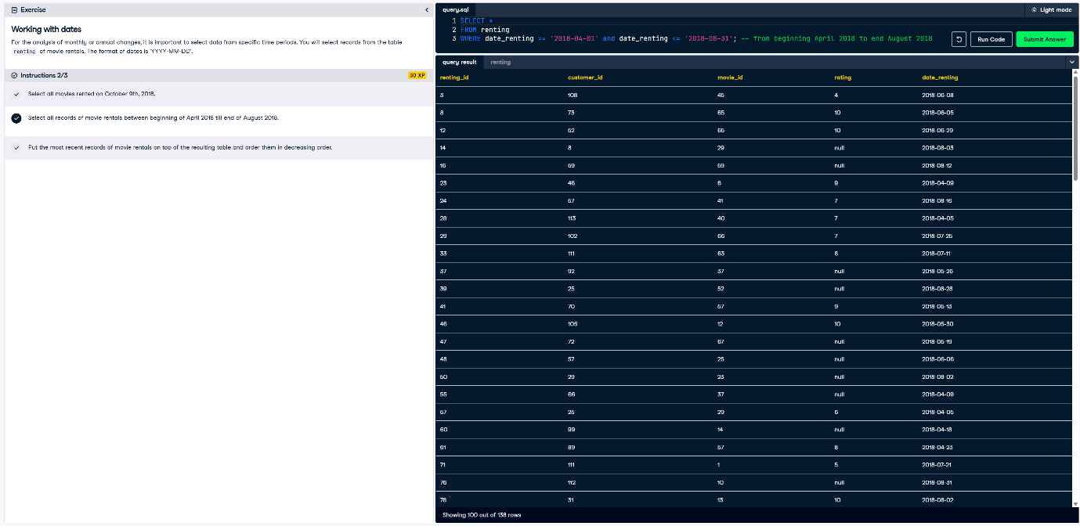

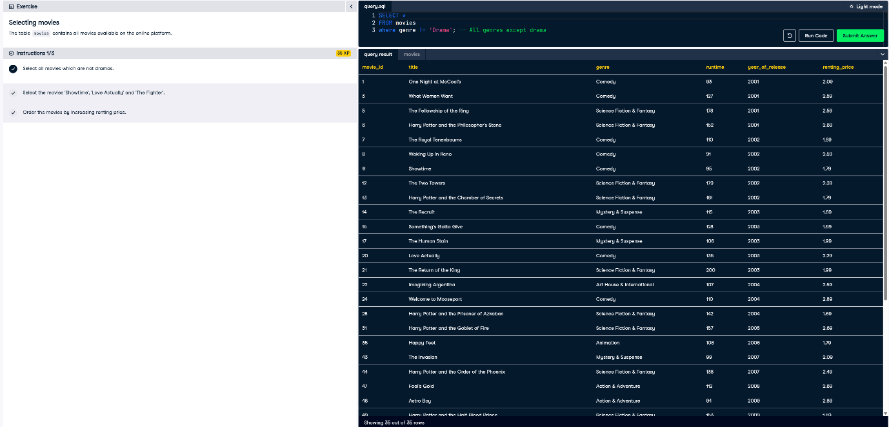

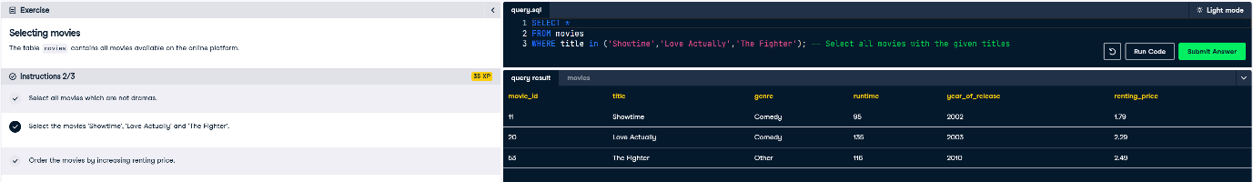

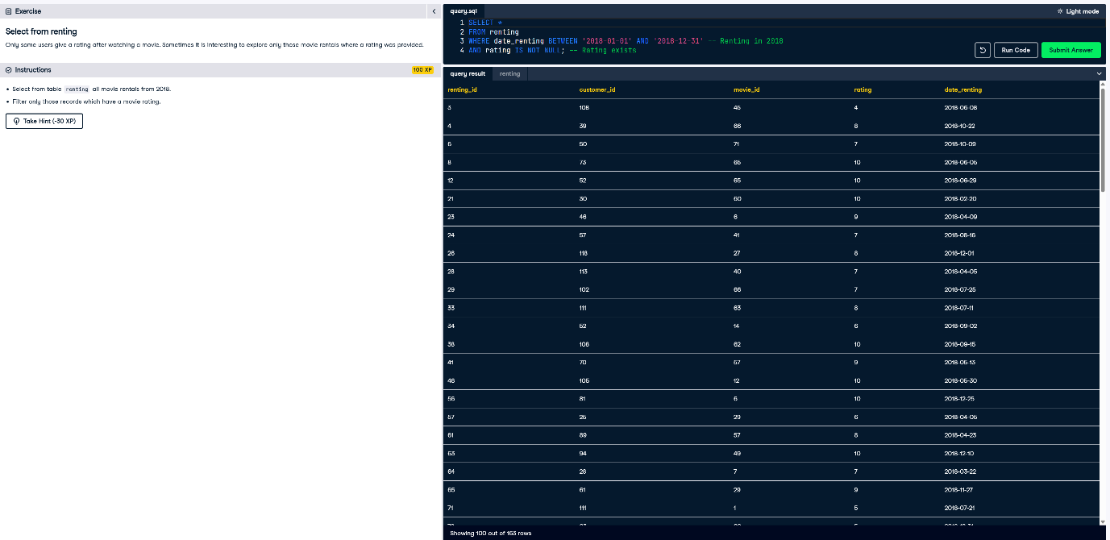

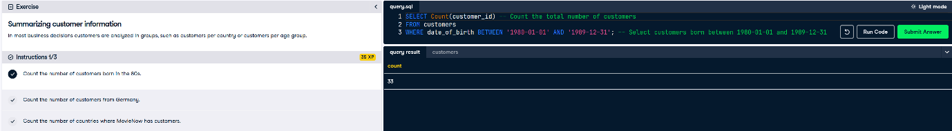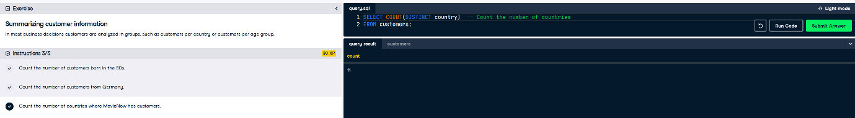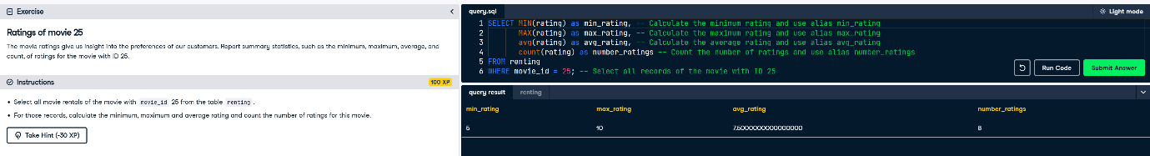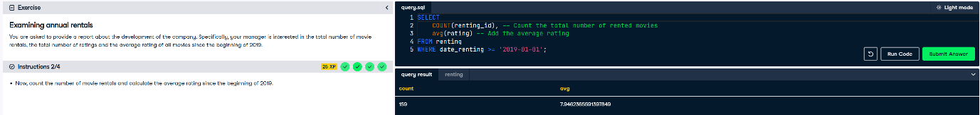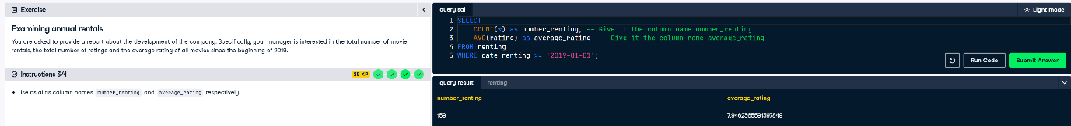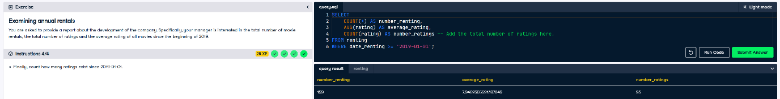

**Decision Making with simple SQL queries**

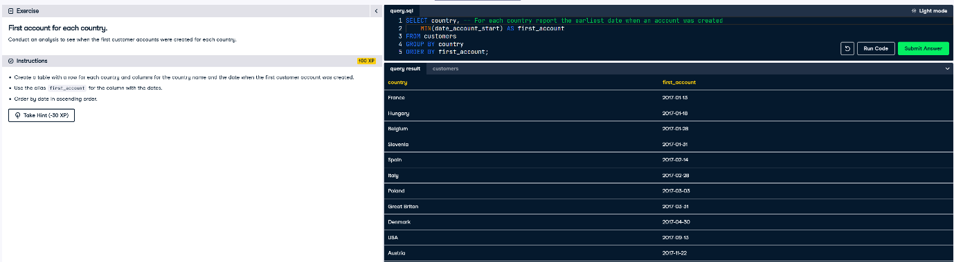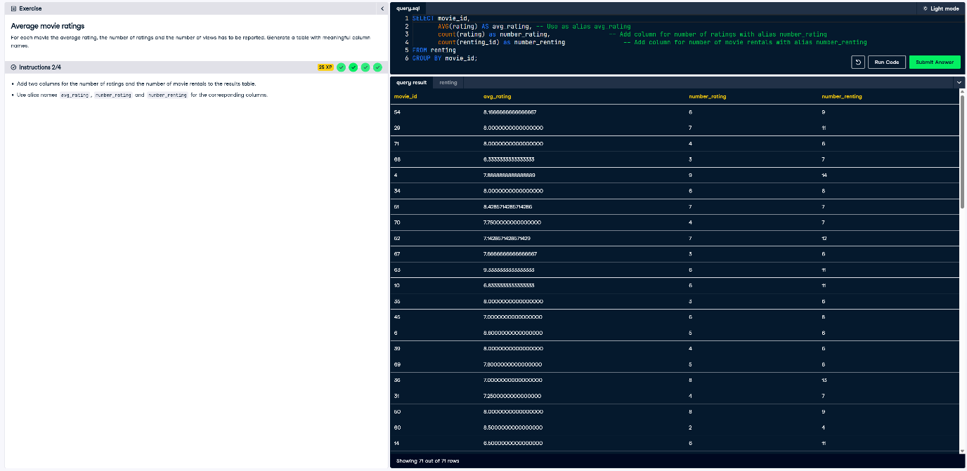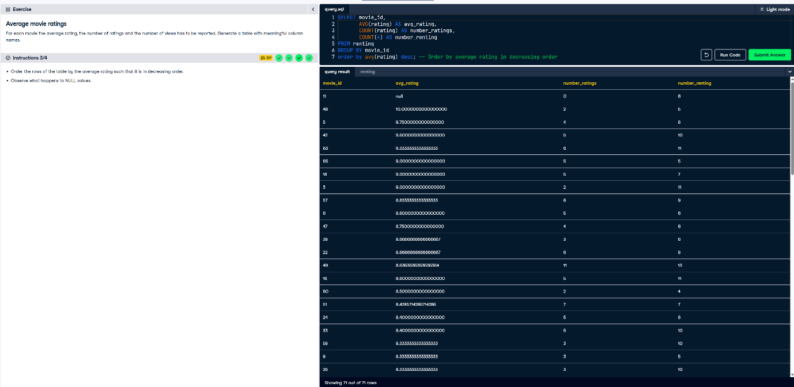

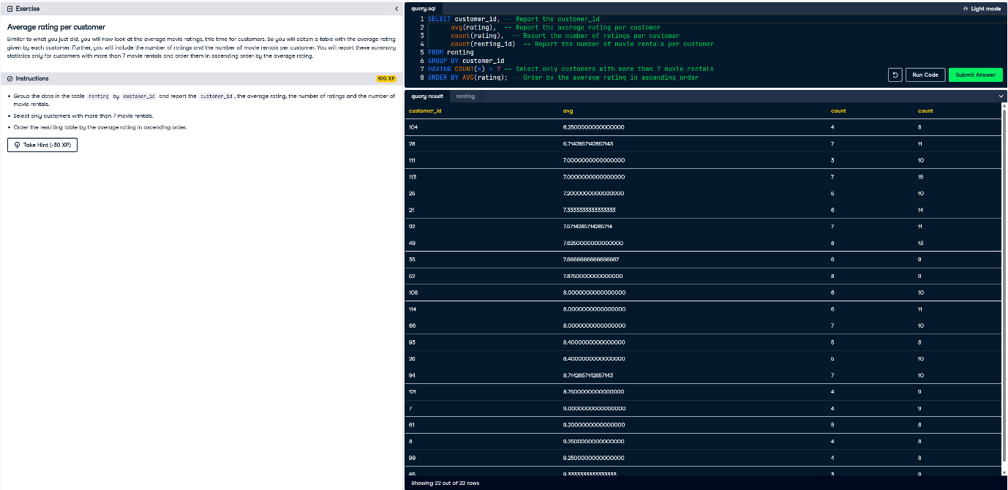

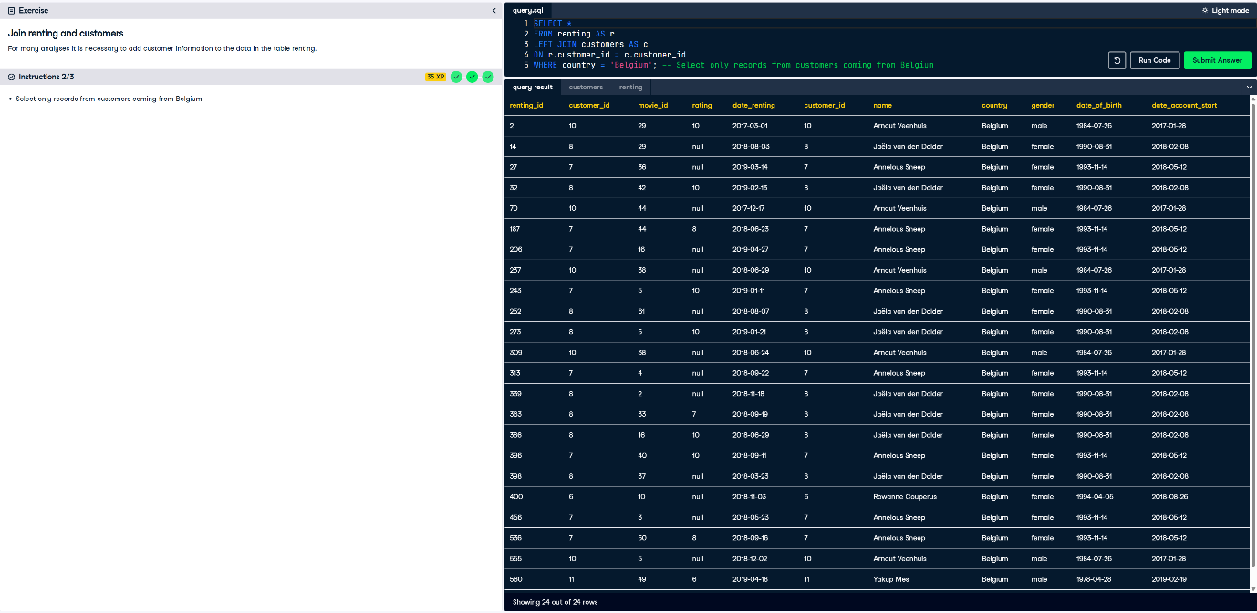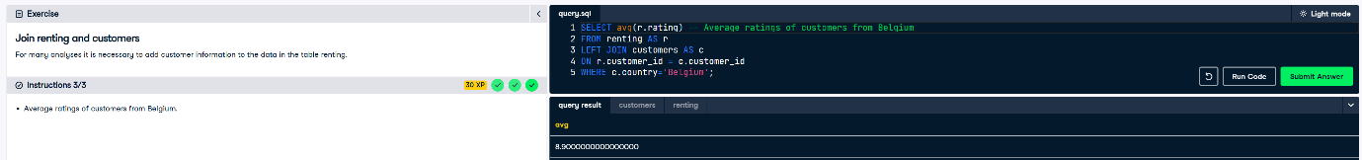

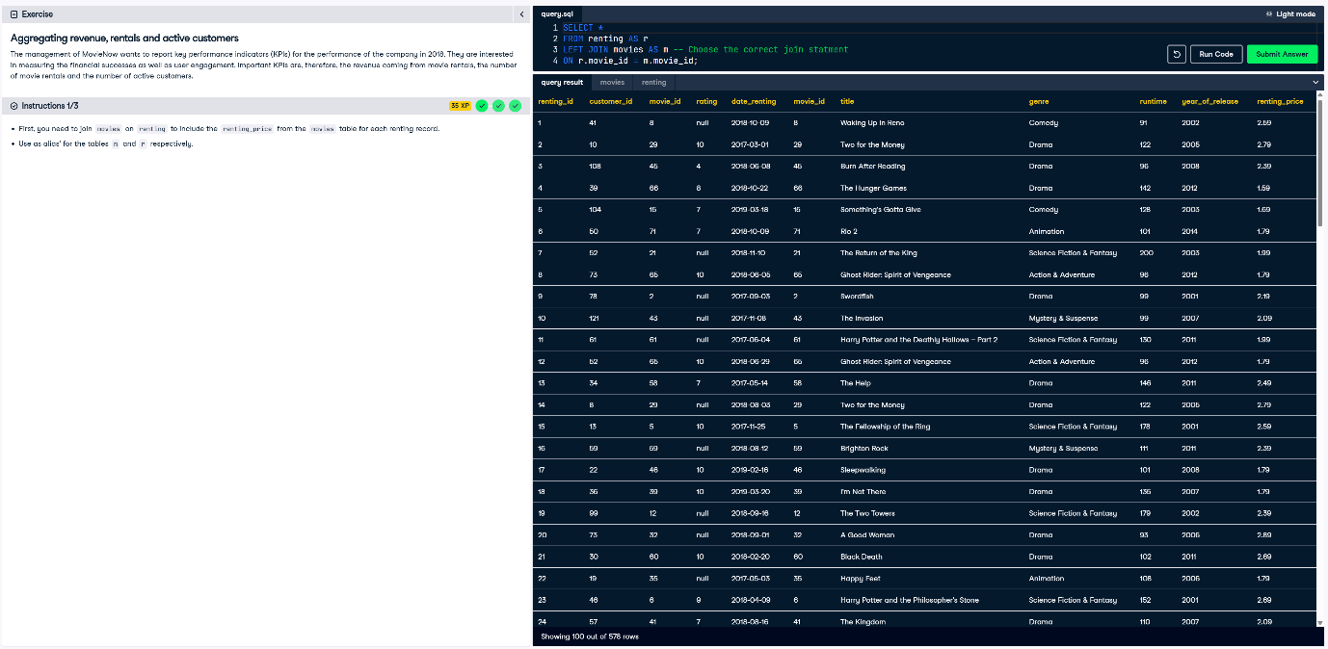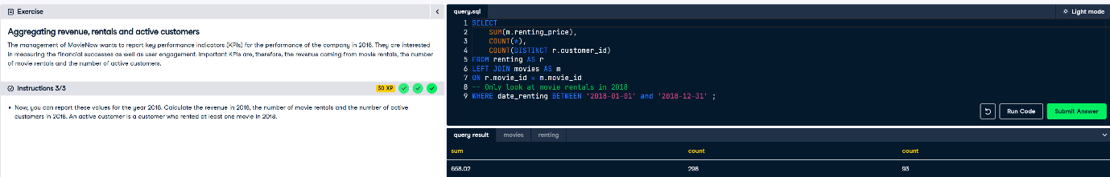

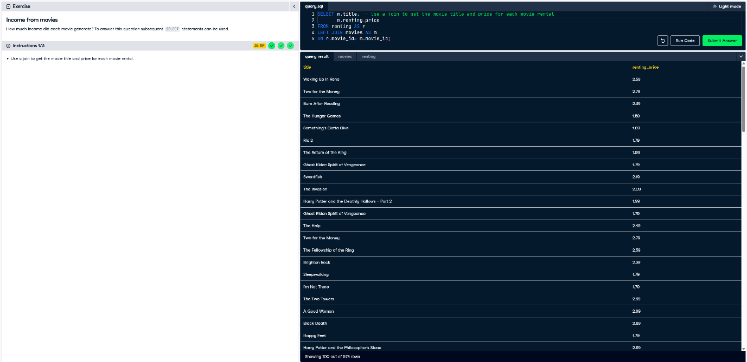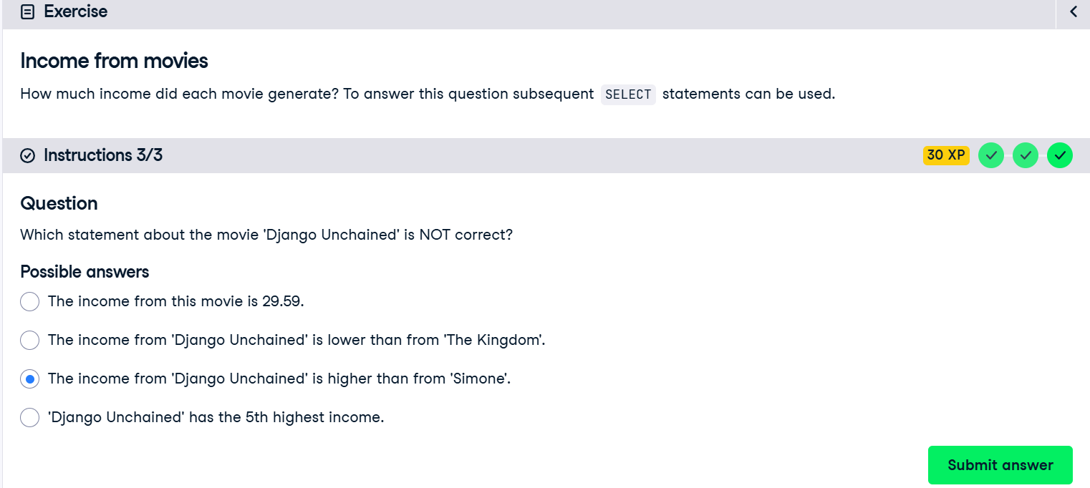

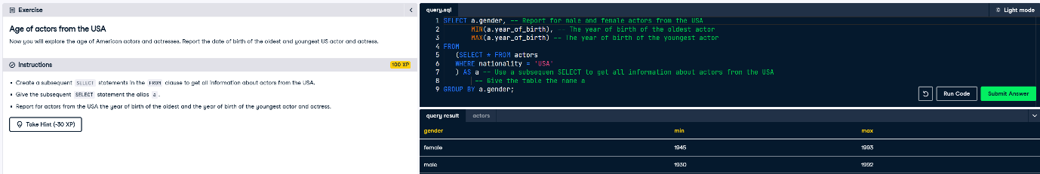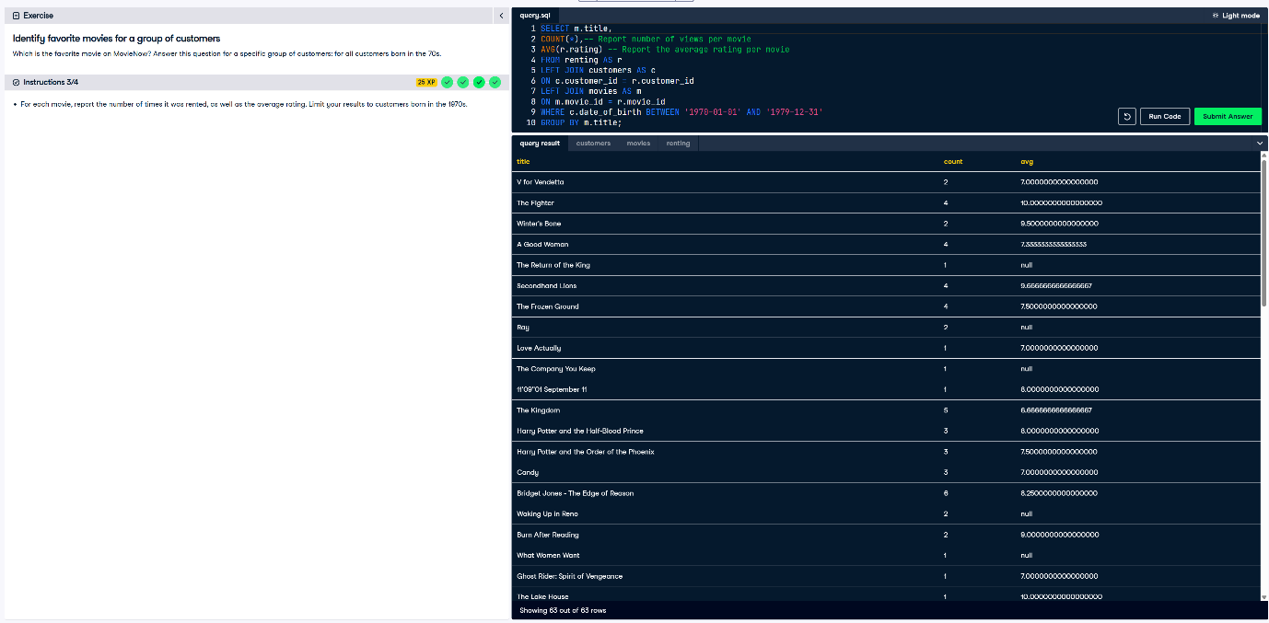

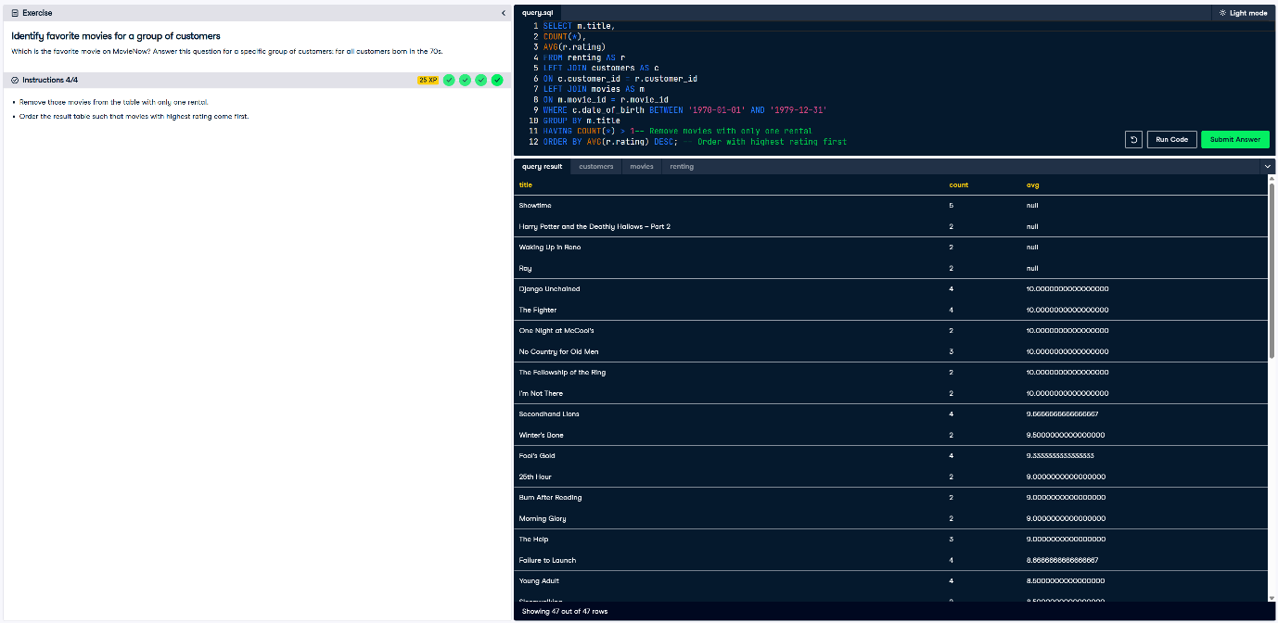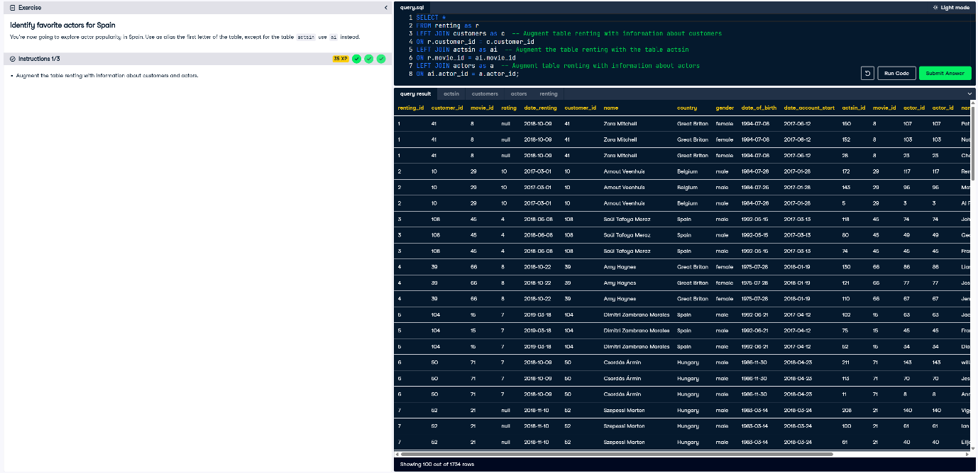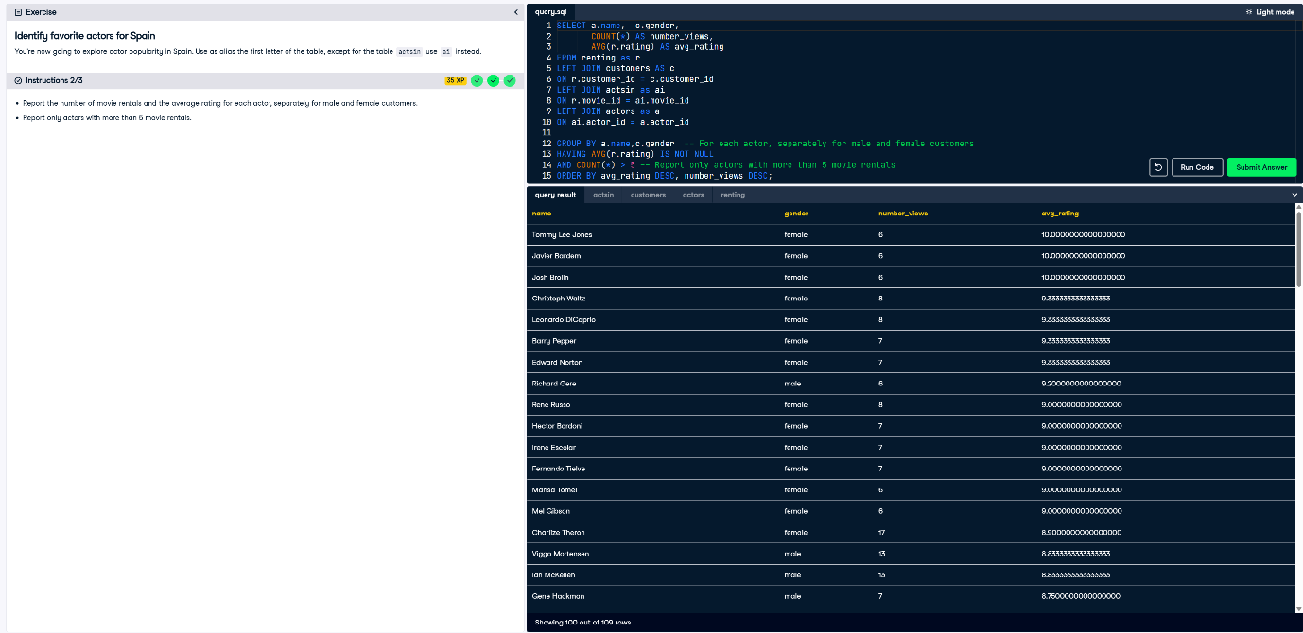

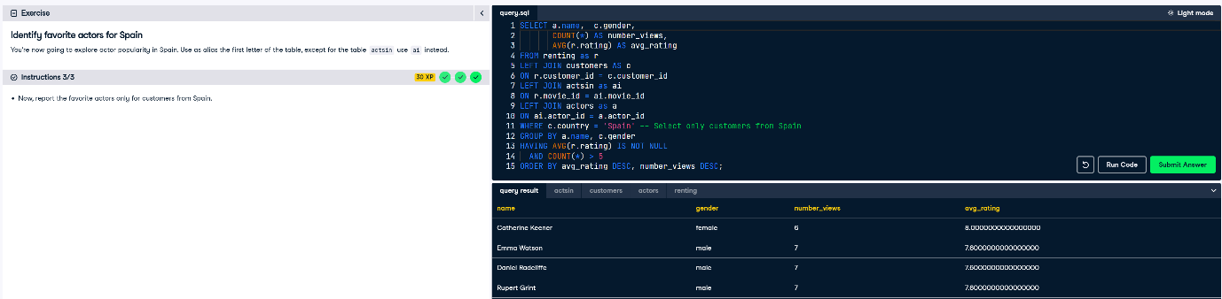

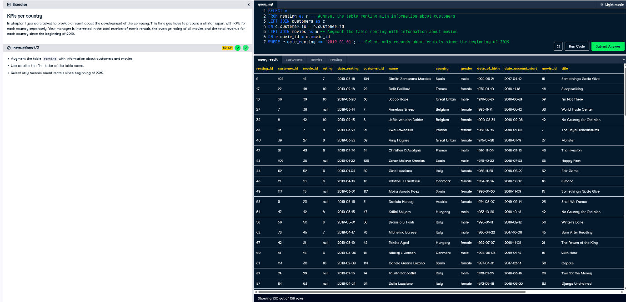

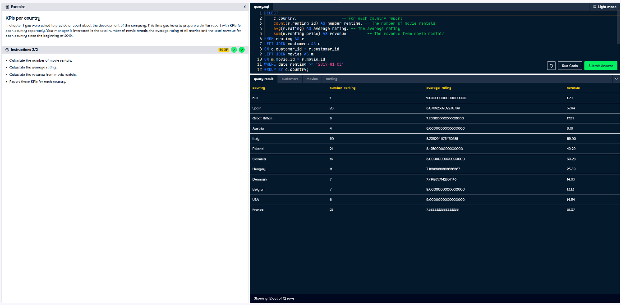

**Data Driven Decision Making with advanced SQL queries**

